AI Marketing Agent — Implementation Milestones
Sep 30, 2026 · @akshat

1. Summary
The build takes 12 weeks in seven milestones, with five CTO sign-off gates; outreach starts only in week 6, after the sending domain has warmed up. Dates below assume a start on Monday 5 October 2026 and 1.5–2 engineers, as in the research proposal; both are to be confirmed.
Milestone | Weeks | Dates (2026) | Outcome
M1 Foundations | W1–W2 | 5–18 Oct | Repository, CI, database, private LLM endpoint, Slack app skeleton, health checks
M2 Lead discovery and approvals | W3–W5 | 19 Oct–8 Nov | Leads found, qualified and accepted in Slack; contacts verified; read-only dashboard
M3 Domain warm-up | W3–W6 | 19 Oct–15 Nov | Outreach domain and mailboxes authenticated and warmed
M4 Outreach pilot | W6–W8 | 9–29 Nov | Approved emails sent at low volume; unsubscribe and caps proven
M5 Reply agent | W7–W9 | 16 Nov–6 Dec | Replies classified, acknowledged, and drafts sent to Slack
M6 Content engine | W8–W11 | 23 Nov–20 Dec | Two posts published through the full pipeline
M7 Hardening and review | W11–W12 | 14–27 Dec | Runbooks, failure drills, metrics review, scale decision
Assumptions
- The GPU machine and its network access are available in week 1.
- Sales and engineering reviewers are named before M2 starts, because Slack approvals need people to answer them.
- November festival holidays and year-end leave will cost some days; the plan carries about one week of slack inside M6 and M7 rather than as a separate buffer.
- Weeks are Monday to Sunday; a gate is reviewed in the last working days of its week.

2. Milestone timeline
Domain warm-up runs alongside lead discovery so the domain is ready when the first approved emails go out in week 6, and the reply agent starts one week into the pilot so it sees real replies.
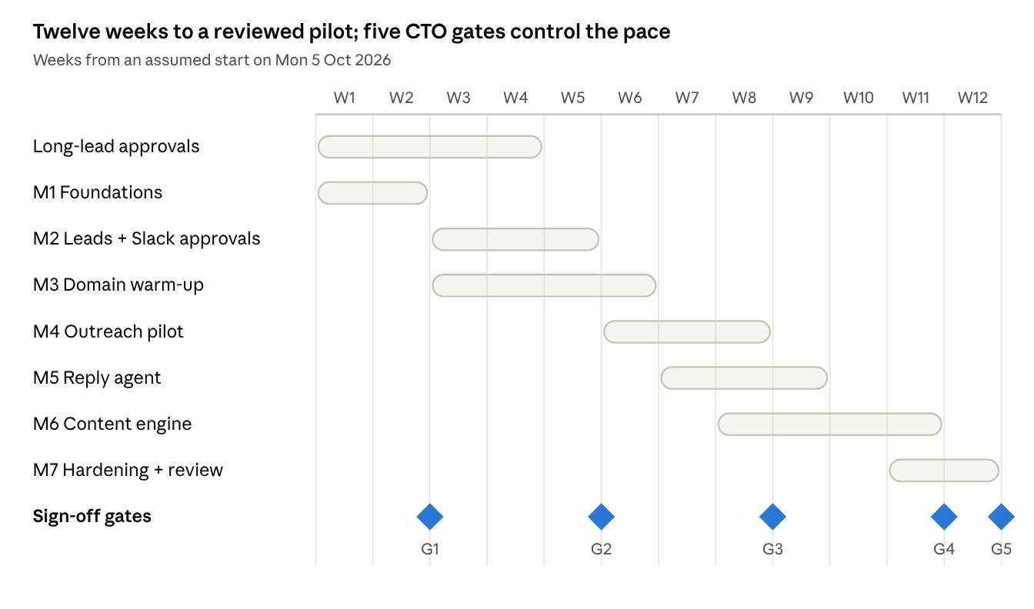
milestone timeline · 8 lanes, 5 gates, 12 weeks
Diamonds mark the gates: G1 after M1, G2 after M2, G3 after the outreach pilot, G4 after the reply agent and the first two published posts, G5 after hardening and the scale decision. Each gate is a CTO review of the exit criteria in section 3 and the metrics in section 6.

3. Milestone details
Each milestone ends with a demonstration and a gate; unchecked exit criteria block the next milestone from scaling. Tasks are listed in the order they should be done.

M1 Foundations (W1–W2)
Goal: a working skeleton where a scheduled job can call the private model, write to the database and post to Slack.
- ☐ Create the private repository, branch protection, pre-commit (ruff, mypy) and CI that runs tests
- ☐ Write Supabase migrations for all table groups, status columns, unique constraints and Row Level Security
- ☐ Set up the Supabase dev and prod projects and the pooled connection string for Actions
- ☐ Install vLLM on the GPU machine as a service; load the primary, fast and embedding models
- ☐ Join the GPU machine to Tailscale; set ACLs; add the Tailscale step to a test workflow
- ☐ Build the shared llm client with task routing, schema validation, timeouts and retries
- ☐ Build the first evaluation set (40 job posts) and the runner; record baseline scores for the candidate models
- ☐ Create the Slack app, channels and the signed-interaction Edge Function with a test button
- ☐ Build the health workflow and agent_runs logging; alerts to #agent-alerts
Exit (Gate 1): a test workflow calls the model from GitHub over Tailscale, writes a row, and a Slack button click updates it exactly once; primary model chosen from the baseline scores.

M2 Lead discovery and approvals (W3–W5)
Goal: qualified companies appear in Slack and are accepted into the database with verified contacts.
- ☐ Career-page collectors for Greenhouse, Lever, Ashby and Workable feeds, with keyword sets for AOSP, BSP, embedded Linux, Yocto and Android Automotive
- ☐ GitHub collector for organisations with AOSP forks, device trees and kernel or BSP repositories
- ☐ Job-alert mailbox parser (alerts-to-slack) reading email text only, with de-duplication
- ☐ Qualification and extraction prompts; tune against the evaluation set
- ☐ Lead candidate messages with Accept and Ignore; approval expiry
- ☐ contact-enrich: website crawl (robots.txt honoured), published business addresses, MX check, self-hosted Reacher verification
- ☐ Read-only dashboard: leads list, lead detail, run history, Start run buttons
- ☐ Suppression list, country filter and source-URL recording on every contact
Exit (Gate 2): at least 100 qualified companies with verified or manual-outreach contacts; the team rates 80% or more as genuinely relevant.

M3 Domain warm-up (W3–W6)
Goal: a sending domain that mailbox providers trust before we send to prospects.
- ☐ Buy the outreach domain; publish SPF, DKIM and DMARC; configure reverse DNS where the provider allows
- ☐ Create two or three named mailboxes with signatures, company name and postal address
- ☐ Start warm-up in week 3 at about 5 messages a day per mailbox, ramping to 30–40 by week 6
- ☐ Register the domain in Google Postmaster Tools; check authentication results on test messages
- ☐ Build the unsubscribe Edge Function with RFC 8058 headers and a confirmation page
Exit: authentication passes, warm-up counters reach target, no blocklisting.

M4 Outreach pilot (W6–W8)
Goal: send approved, personalised emails at low volume and measure deliverability.
- ☐ outreach-draft with the email prompt, few-shot examples written by the team, and validation checks
- ☐ Email draft messages in Slack with Send, Edit and Skip; Edit modal
- ☐ outreach-send: claim, suppression check, caps, business-hours window, idempotency key, SMTP send
- ☐ Follow-up scheduling (day 3–4 and day 8–10) that stops on any reply
- ☐ Auto-pause on bounce rate above 3% or any spam-complaint signal
- ☐ Send about 300 emails over the pilot, all human-approved
Exit (Gate 3): bounce rate under 3%, no spam complaints, no duplicate sends, unsubscribes processed within the same run.

M5 Reply agent (W7–W9)
Goal: every reply is classified and acknowledged within the hour, and people get a drafted answer for interested leads.
- ☐ IMAP fetch and thread matching by In-Reply-To and References
- ☐ Reply classification against the labelled reply set; out-of-office and bounce handling
- ☐ Automatic acknowledgement for interested and question replies
- ☐ Retrieval over our service descriptions and case studies; reply drafts to #replies with Send, Edit and Skip
- ☐ Unsubscribe replies add to suppression and stop the sequence
Exit: classification meets the accuracy target in section 6; a full reply loop works end to end on test conversations.

M6 Content engine (W8–W11)
Goal: a weekly post moves from topic to published on three channels with an engineer's approval.
- ☐ Stand up the blog (Ghost, Hugo or WordPress) with a CMS API and draft support
- ☐ Topic backlog, brief template and knowledge store with embeddings
- ☐ content workflow: outline, draft, CMS draft, Slack review with Approve and Request changes
- ☐ Publishers: blog (canonical), dev.to with canonical_url, LinkedIn company page post
- ☐ Duplicate check against past posts; weekly metrics pull
- ☐ File the LinkedIn Community Management API application in week 1; use manual posting until approved
Exit (Gate 4, with M5): two posts published through the full pipeline; reply loop signed off.

M7 Hardening and review (W11–W12)
Goal: the system survives failures and the team can run it without us.
- ☐ Failure drills: LLM machine off, Supabase unreachable, Slack down, duplicate button clicks, SMTP errors mid-batch
- ☐ Rotate every secret once using the runbook
- ☐ Write runbooks: resume sending, add or remove a source, replace the GPU machine
- ☐ Review pilot metrics with the CTO; decide volume increase, new sources, paid enrichment
Exit (Gate 5): drills passed, runbooks reviewed, scale decision recorded.

4. Long-lead items to start in week 1
Seven items depend on other people or on outside approval, so they start in week 1 even though the work that needs them comes later. A late answer on any of them delays a gate.
Item | Why it is slow | Owner | Needed by
Outreach domain purchase and DNS access | Warm-up needs 3–4 weeks before pilot volume | CTO or IT admin | W3 start
Mail provider account and mailboxes | Approval and setup lead time | IT admin | W3 start
Slack workspace permission to install a custom app | Admin approval may be required | Slack admin | W1 (M1 needs it)
LinkedIn Community Management API application | Access is reviewed by LinkedIn | Marketing owner | Filed W1; needed W9
Legal review of outreach and data handling | Counsel availability | CTO | Before first send (W6)
GPU machine readiness and network policy for Tailscale | Office network and security sign-off | IT admin | W1
Named reviewers: sales owner and a senior AOSP/embedded engineer | Their time must be reserved | CTO | W3 (leads), W8 (blog)
If the LinkedIn application is not approved by week 9, the content workflow prepares the LinkedIn post text and a team member publishes it manually; nothing else in the plan changes.

5. Roles and responsibilities
Two engineers carry the build; the business roles are small but on the critical path for approvals.
Role | Commitment | Milestones | Responsible for
Backend / ML engineer | Full time, 12 weeks | M1–M7 | LLM serving, prompts, collectors, pipelines, workflows, evaluation sets
Full-stack engineer | Half time from W3 | M1, M2, M4, M6 | Slack app and Edge Functions, dashboard, Supabase Auth and RLS, unsubscribe page
Sales / BD owner | About 30 minutes a day from W3 | M2, M4, M5 | Accepting leads, approving emails and reply drafts, labelling evaluation data
Senior AOSP/embedded engineer | 2–3 hours a week from W8 | M6 | Blog briefs, technical review, checking reply drafts on technical questions
IT admin | As needed, mostly W1–W3 | M1, M3 | Domain, mailboxes, network, Slack app approval
CTO | Gate reviews; legal and scale decisions | All gates | Sign-off at each gate
Legal counsel | One review before W6 | M4 | Outreach and data-protection check

6. Acceptance criteria and pilot metrics
Each gate has a number to hit, measured on real pilot data or the labelled evaluation sets. Targets marked proposed need CTO confirmation.
Area | Metric | Target | Measured at
Lead quality | Share of accepted leads the team rates relevant | 80% or more | Gate 2
Lead volume | Qualified companies with contact or manual route | 100 or more | Gate 2
Qualification | Agreement with labelled job posts (evaluation set of 40) | 85% or more (proposed) | Gate 1 and on every prompt change
Deliverability | Hard bounce rate | Under 3% | Gate 3
Deliverability | Spam complaints | None; hard stop at 0.3%, target under 0.1% | Gate 3
Safety | Duplicate sends; sends to suppressed addresses | Zero | Gate 3
Unsubscribe | Opt-outs applied before the next send | 100% | Gate 3
Reply handling | Classification agreement (labelled set of 40) | 90% or more (proposed) | Gate 4
Reply speed | Time from reply to acknowledgement | Within 1 hour | Gate 4
Content | Posts published through the full pipeline | 2 | Gate 4
Reliability | Failure drills passed | All listed in M7 | Gate 5
Engagement (informational) | Positive reply rate over about 300 emails | Recorded, no pass mark | Gate 5

7. Schedule risks and fallbacks
The schedule is most exposed to things outside the engineers' control: approvals, mail reputation and reviewer time. Each risk has a fallback that keeps later milestones moving.
Risk | Affects | Signal | Fallback
Slack app install blocked by admin policy | M1, all approvals | No approval by end of W1 | Use a workspace where we are admin, or a dedicated Slack workspace for the agent
Domain warm-up slower than planned | M4 | Inbox placement or bounce problems in W5 | Extend warm-up by a week; hold pilot volume at 20 a day
Reviewers slow to answer Slack approvals | M2, M4 | Approvals expire unanswered | Named backup approver; reduce daily batch; expire after 72 hours as designed
Local model too weak for email or blog quality | M4, M6 | Evaluation scores below target in M1 | Try the alternative primary model; then a larger model on the 80 GB tier
GPU machine outages or power cuts | All LLM workflows | Health check failures | UPS; catch-up from queue; rented GPU for the daily window as a stopgap
Email finding yields few valid addresses | M2, Gate 2 | Verified share of contacts under 40% by W4 | More role addresses and manual routes; discuss paid enrichment at Gate 2
LinkedIn API access delayed | M6 | Application unanswered by W8 | Manual LinkedIn posting from prepared text
Legal review raises restrictions | M4 | Comments on region or content rules | Restrict target regions; add required footer text; delay first send until resolved
Festival holidays and year-end leave | M6, M7 | Team availability in Nov and Dec | Move content work earlier; keep Gate 5 review in the first week of January if needed
Scope growth (extra sources, dashboard features) | All | New requests during build | Log them in the backlog in section 9; nothing enters before Gate 3 without CTO approval

8. Go-live checklist
Nothing sends to a real prospect until every item here is checked. The list is reviewed at the start of week 6.
- ☐ SPF, DKIM and DMARC pass on test messages to Gmail, Outlook and a corporate mailbox
- ☐ Unsubscribe link and one-click header work end to end and land in the suppression list
- ☐ Suppression check runs inside the same transaction as marking an email sending
- ☐ Daily and per-mailbox caps enforced in the database
- ☐ Auto-pause tested with simulated bounces
- ☐ Every email carries company name, postal address and the reason for contact
- ☐ Target-region filter set as agreed after legal review
- ☐ Dev and prod are separate; dev cannot send outside the internal allow-list
- ☐ Slack channels private; approver allow-list reviewed
- ☐ #agent-alerts tested with a forced failure
- ☐ Supabase Pro plan active with backups; RLS verified on every table
- ☐ Privacy notice page published on our website

9. After the pilot
These items are deliberately not in the 12 weeks; they enter the plan only after the Gate 5 decision.
- Additional lead sources, such as event exhibitor lists and SoC vendor partner pages
- Company-level ad targeting on Google and LinkedIn, subject to legal review
- Auto-approval of first emails for high-fit leads after a clean quality record
- Paid contact enrichment if verified-contact coverage is too low
- Multi-language outreach and region-specific templates
- A fuller dashboard: pipeline stages, source performance, cost per qualified lead
- Fine-tuning or prompt libraries per service line (AOSP, BSP, automotive)

